3.5" External SATA Hard Disk ENCLOSURE

Simply Add Your Own 3.5" Hard Disk
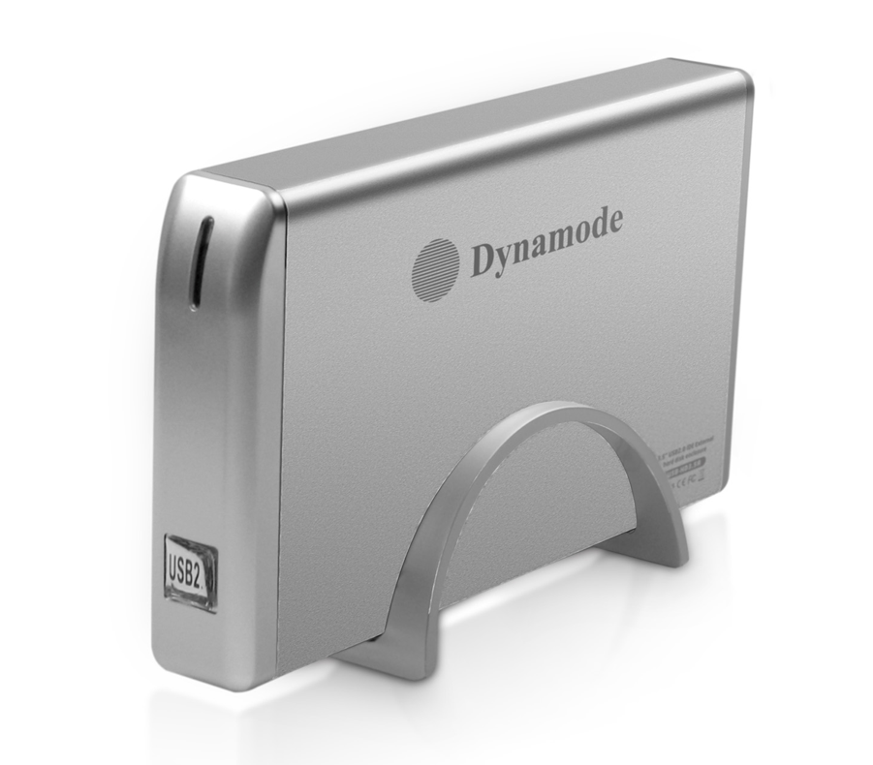

DESCRIPTION
The exciting new USB-HD3.5SI-1A is a stylish, high quality aluminium Disk Enclosure with totally silent operation. The newly designed Aluminium enclosure acts as a built-in heatsink, effectively reducing heat output of the enclosed Hard Disk to enhance reliability and lifespan. Unique 1-Button Backup facility on the Enclosure allows the User to select the files and directories they want to Backup or Restore (Windows only), makes saving your data as easy as just pressing a button!

FEATURES
> Stylish and portable aluminum design
> Ideal for your existing 3.5" interfaced hard disk drives
> Re-use your PC, Server or Mac hard disk and keep your data
when you upgrade
> Plug n' Play for popular Operating Systems -
no drivers needed
> External PSU supplied
> Backup and restore your data at up to 480Mbps

SPECIFICATIONS
Transfer interface: USB2.0
Transfer data: 480Mbps(MAX)
One touch backup OTB button
Hard disk type: 3.5" IDE or SATA interfaced hard disk
Working temperature: -40 ~ 65℃
Working humidity: 8% ~ 90%
Storage humidity: 5% ~ 95%
Operating systems: Windows98/ME/2000/XP/VISTA/7/8/10, Mac OS 8.6 or above

